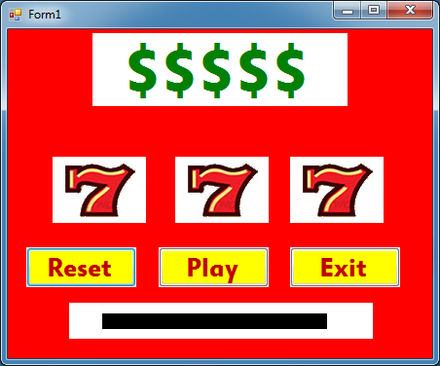

Private Sub btnExit_Click(sender As System.Object, e As System.EventArgs) Handles btnExit.Click

Application.Exit()

End Sub

Private Sub btnReset_Click(sender As System.Object, e As System.EventArgs) Handles btnReset.Click

picSlot1.Image = picFace1.Image

picSlot2.Image = picFace1.Image

picSlot3.Image = picFace1.Image

End Sub

Private Sub btnPlay_Click(sender As System.Object, e As System.EventArgs) Handles btnPlay.Click

Dim d1 As Integer = Rnd() * 6 + 1

Dim d2 As Integer = Rnd() * 6 + 1

Dim d3 As Integer = Rnd() * 6 + 1

'Slot1'

If d1 = 1 Then picSlot1.Image = picFace1.Image

If d1 = 2 Then picSlot1.Image = picFace2.Image

If d1 = 3 Then picSlot1.Image = picFace3.Image

If d1 = 4 Then picSlot1.Image = picFace4.Image

If d1 = 5 Then picSlot1.Image = picFace5.Image

If d1 = 6 Then picSlot1.Image = picFace6.Image

'Slot2'

If d2 = 1 Then picSlot2.Image = picFace1.Image

If d2 = 2 Then picSlot2.Image = picFace2.Image

If d2 = 3 Then picSlot2.Image = picFace3.Image

If d2 = 4 Then picSlot2.Image = picFace4.Image

If d2 = 5 Then picSlot2.Image = picFace5.Image

If d2 = 6 Then picSlot2.Image = picFace6.Image

'Slot3'

If d3 = 1 Then picSlot3.Image = picFace1.Image

If d3 = 2 Then picSlot3.Image = picFace2.Image

If d3 = 3 Then picSlot3.Image = picFace3.Image

If d3 = 4 Then picSlot3.Image = picFace4.Image

If d3 = 5 Then picSlot3.Image = picFace5.Image

If d3 = 6 Then picSlot3.Image = picFace6.Image

End Sub

End Class